Market Monitor - Bangladesh - 2026-05

Highlights
The Bangladesh market showed signs of price stabilization in May after a year of significant deflation. Volatile but offsetting monthly price movements in key commodities resulted in only a minor increase in the overall food basket, which remains well below last year's levels.
The cost of a typical food basket rose slightly to BDT 1,500.84 (↑0.6% MoM) but remains down significantly from the previous year (↓9.2% YoY).
Commodity price movements were mixed:
- Onions (imported, China): Prices plummeted month-on-month (↓23.6%).
- Eggs (brown): Experienced a sharp monthly price surge (↑16.1%).
- Chili (whole, dry, Indian Teja): Continued its strong inflationary trend, rising substantially over the year (↑31.0% YoY).
Key market drivers this month include:
- Significant Annual Deflation: The year-on-year decrease in the food basket was primarily driven by major price reductions in sugar (↓52.3%), eggs (↓33.2%), and broiler chicken (↓31.3%).
- Volatile Monthly Price Shifts: A sharp increase in egg prices (↑16.1%) was largely offset by steep declines in imported onions (↓23.6%) and chickpeas (↓17.0%), keeping the overall basket relatively stable.
- Persistent Inflation in Select Items: Despite the general deflationary trend, prices for items like dry chili (↑31.0% YoY) and fortified soybean oil (↑11.5% YoY) continued to rise, indicating specific supply-side pressures.
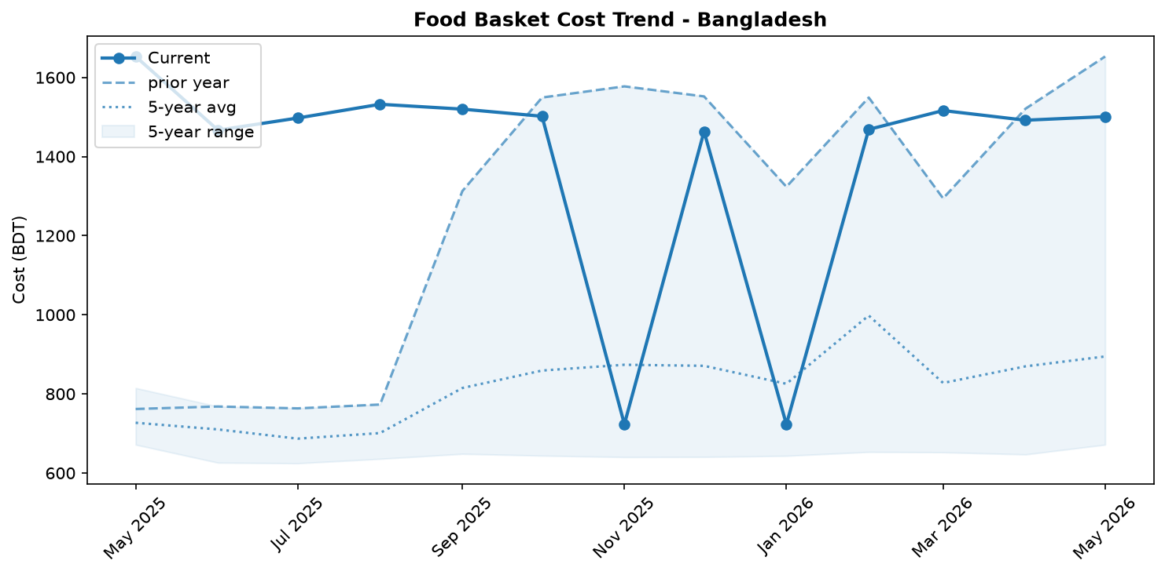
Food basket cost trend

Market Overview
The Bangladeshi market demonstrated overall stability in May 2026, though this top-level view conceals significant volatility within individual commodities. The national food basket, while experiencing a slight month-on-month increase of 0.6%, remains down a substantial 9.2% year-over-year. This annual deflation has been primarily driven by sharp price reductions in key staples such as sugar (-52.3%), eggs (-33.2%), and chicken meat (-31.3%). However, the recent monthly uptick suggests this strong deflationary trend may be slowing. Conflicting price signals are a defining feature of the current market. For instance, a sharp monthly surge in egg prices (+16.1%) was largely offset by plummeting onion (-23.6%) and chickpea (-17.0%) costs. Similarly, divergent fuel price trends, with diesel costs decreasing (-2.1%) while petrol prices rose sharply (+9.6%), create an uncertain outlook for logistics and transport-related inflation. The Bangladeshi Taka remained stable against the US dollar, helping to contain the cost of imports in the short term, but a gradual annual depreciation continues to pose a long-term risk. The market is likely entering a period of price stabilization, characterized by commodity-level fluctuations rather than a return to the deep deflation seen over the past year.

Commodity Analysis
An analysis of individual commodities reveals a market of stark contrasts. The overall food basket's slight 0.6% monthly increase, following a year of significant deflation (-9.2% YoY), points towards a potential stabilization of prices. Eggs were a primary driver of the monthly uptick, with prices surging 16.1%. This highlights the commodity's inherent volatility, as it comes against a backdrop of a 33.2% price collapse over the past year. Providing significant downward pressure, imported onion prices plummeted by 23.6% month-on-month, effectively counteracting the rise in eggs and stabilizing the overall basket. This sharp drop suggests a recent improvement in supply chains or a decrease in demand. Over the longer term, sugar has been the single largest contributor to annual deflation, with its price having fallen a dramatic 52.3% year-over-year; it remained stable this month with a negligible 0.2% increase. In stark contrast to the deflationary trend seen in most items, Indian Teja chili continues its inflationary trajectory. Its price rose 3.1% in May and is up a substantial 31.0% compared to the previous year, making it a notable outlier in the food basket and a persistent source of price pressure for consumers.
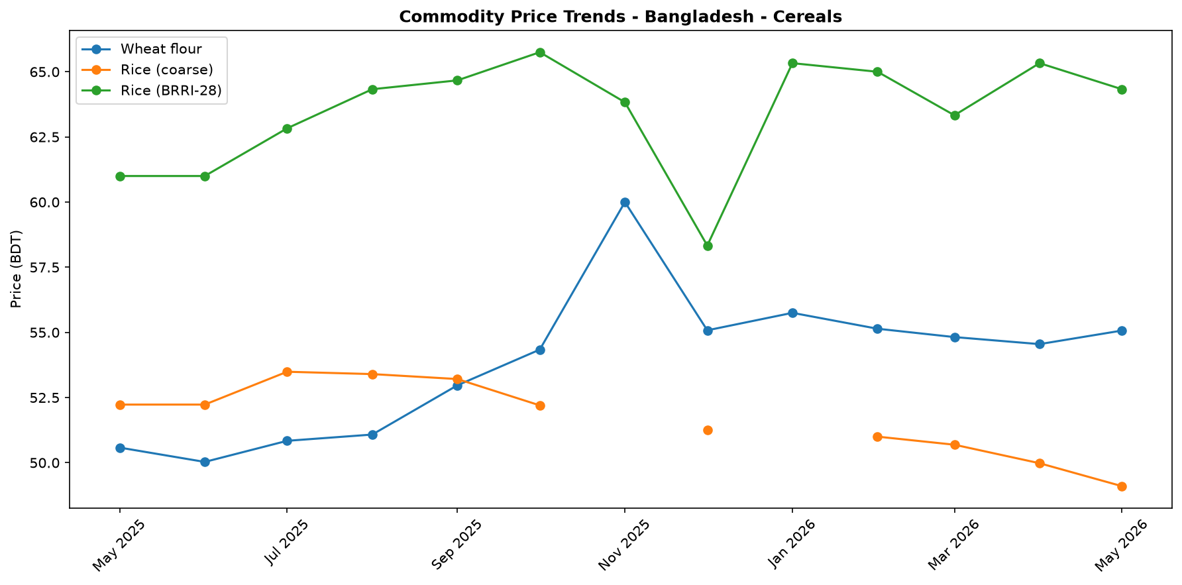
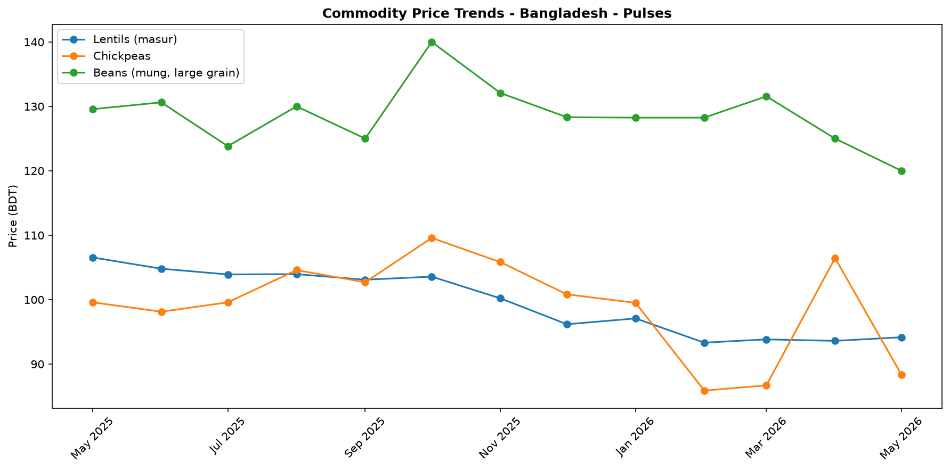
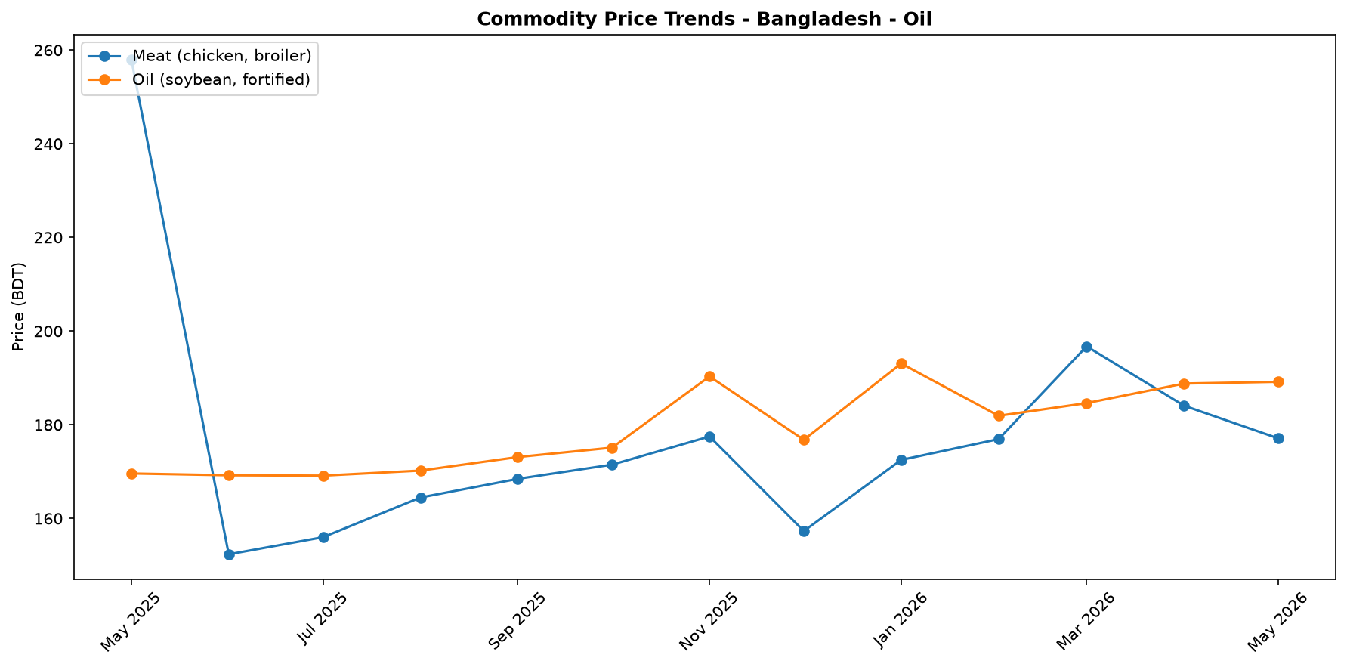
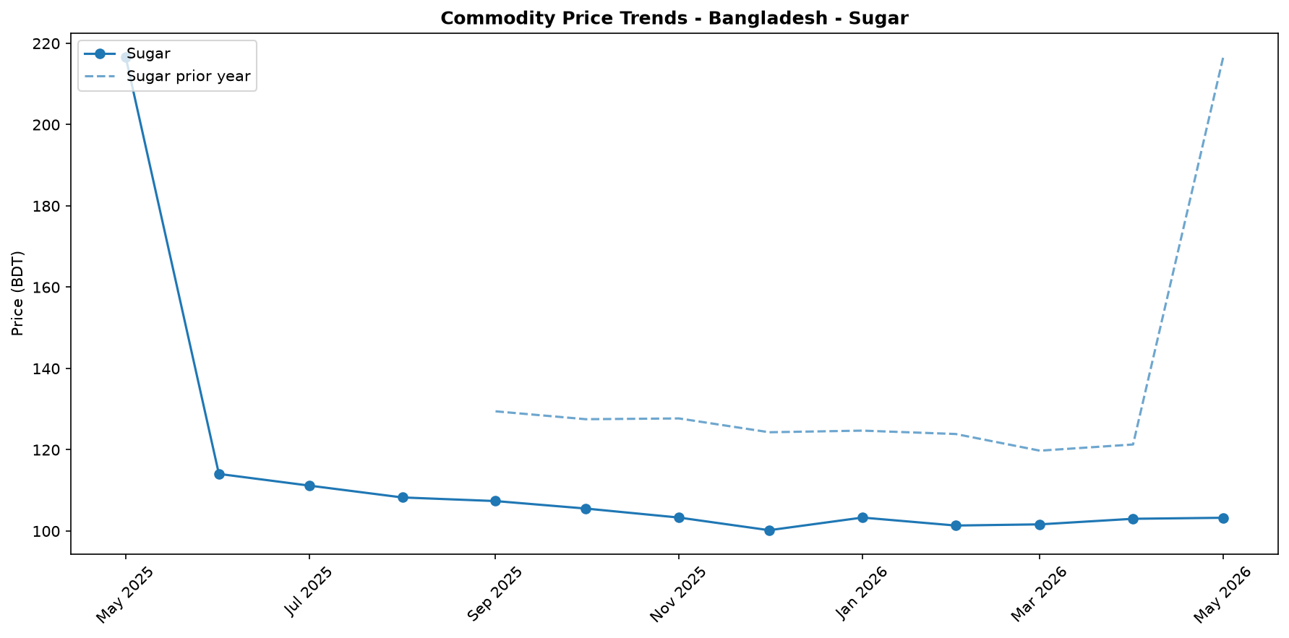
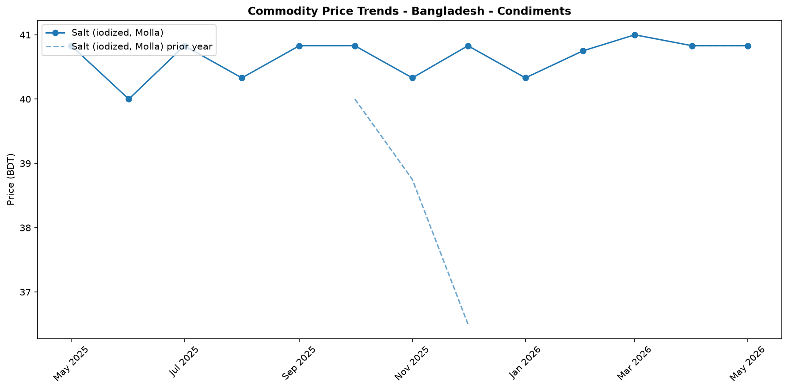
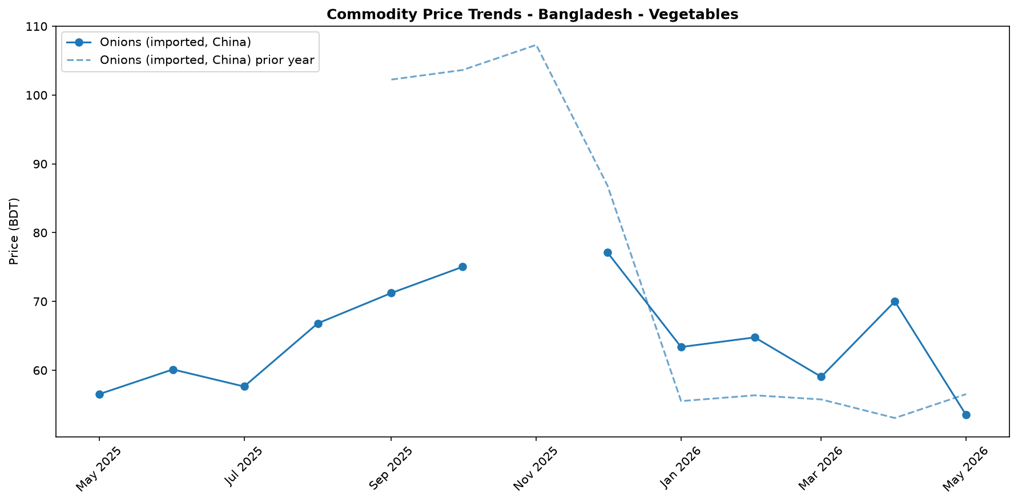
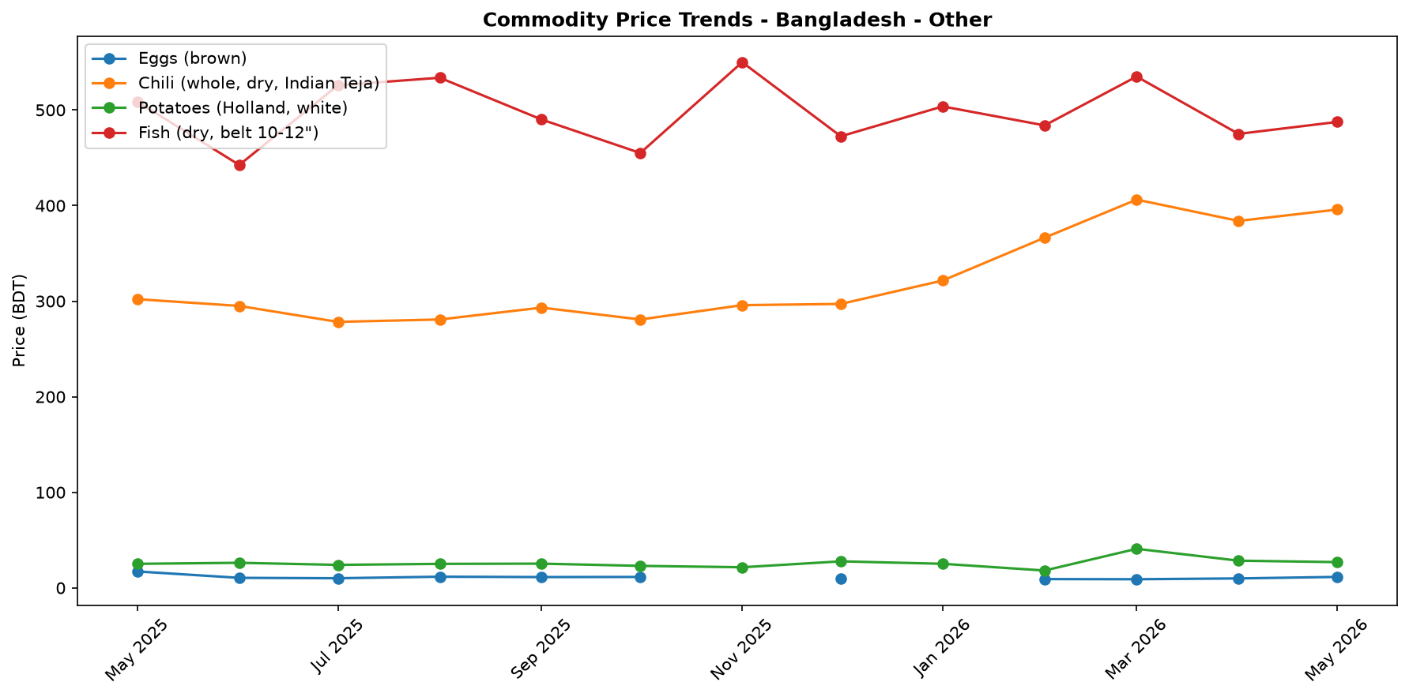

Regional Highlights
The analysis presented in this report is based on national-level data, as no significant regional price disparities for the core food basket were reported in May 2026. The national average is therefore considered representative of market conditions across the country's major divisions. While price data does not show regional variation, significant economic activities with potential local market impacts were noted, particularly in the Cox's Bazar region. During the month, the UN and its partners launched a major appeal for USD 710.5 million to support Rohingya refugees and their host communities. This was complemented by a direct contribution of EUR 2 million from the Government of Finland to UNHCR for the same purpose. These large-scale funding initiatives represent a substantial economic injection into the region, influencing local livelihoods, purchasing power, and demand for goods and services. While not directly reflected in the national price trends, such events are critical drivers of the local economy in the Cox's Bazar division.
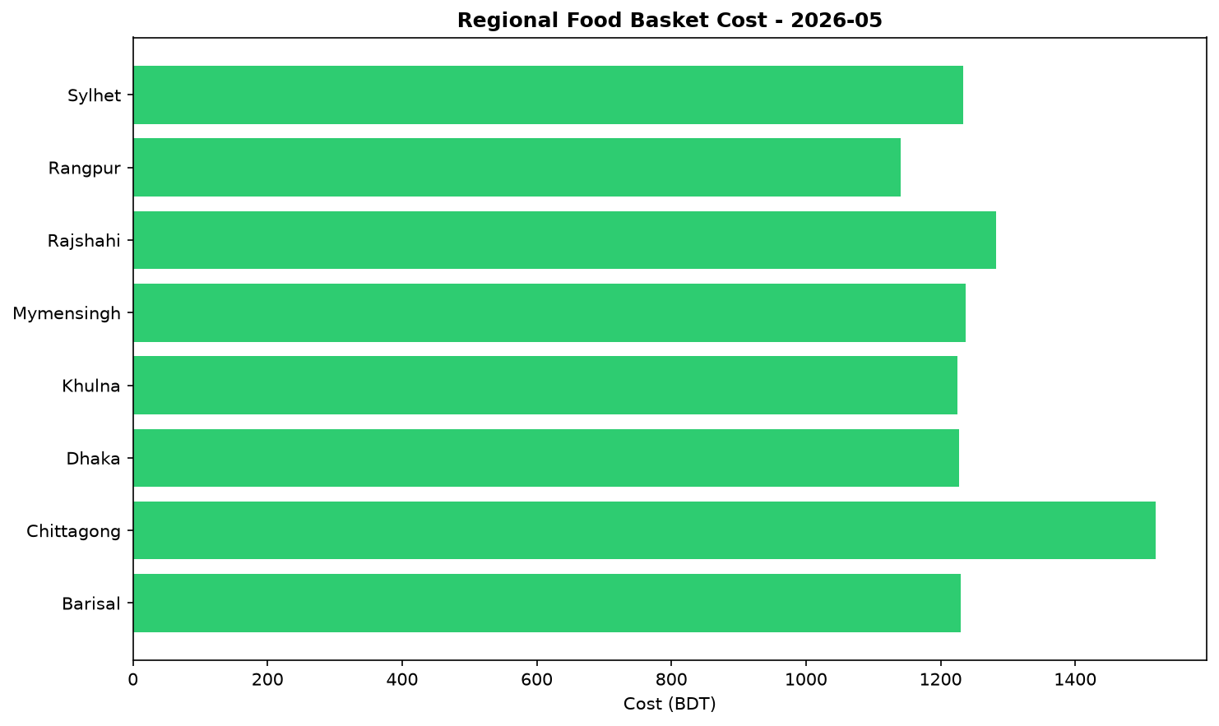

Exchange Rate Analysis
The Bangladeshi Taka (BDT) remained stable, trading at 122.75 per US dollar. A marginal month-on-month depreciation of 0.04% had a negligible effect on the cost of imports. However, a year-on-year comparison reveals a 0.45% depreciation, indicating a slight but persistent weakening trend over the longer term. This recent stability helps contain immediate price shocks for imported essential commodities such as wheat, cooking oil, and fuel, which are crucial for food security. Nonetheless, the gradual annual depreciation continues to exert modest upward pressure on the domestic prices of these goods. The stability is a positive factor for short-term price predictability, but the long-term depreciation trend remains a point of concern for the affordability of imported food and fuel.

Fuel & Energy
In May 2026, the national retail price of diesel decreased by 2.1 percent month-on-month to BDT 120.25 per litre, though it remained 7.1 percent above last year's level, while petrol prices rose by 9.6 percent to BDT 145.25 per litre. The monthly decline in diesel prices is likely consistent with an easing of administered price pressures by the government. This reduction in diesel, a key fuel for transport and irrigation, may help to lower food production and distribution costs, but the concurrent sharp increase in petrol prices presents a conflicting inflationary pressure on transport costs for households and businesses.
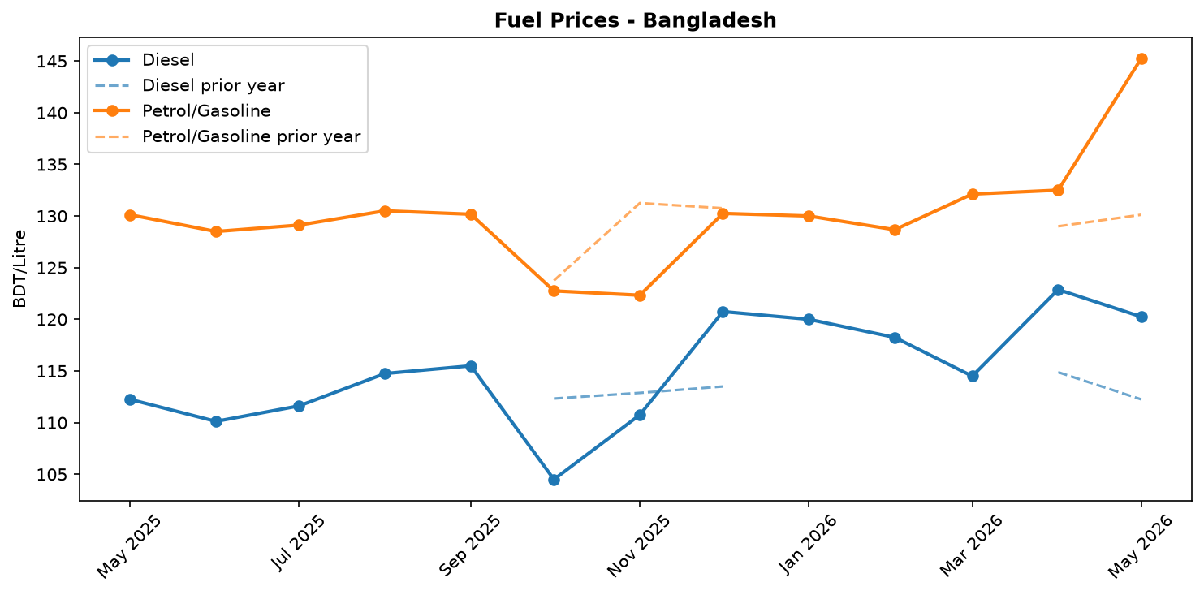
Fuel retail price trend

References
- [rw_4214182] ReliefWeb (2026-05-31) Finland boosts support for Rohingya refugees with EUR 2 million contribution [EN/BN]
https://reliefweb.int/node/4214182
- [rw_4214118] ReliefWeb (2026-05-29) Period poverty: A global menstrual health crisis
https://reliefweb.int/node/4214118
- [rw_4213869] ReliefWeb (2026-05-28) Asia and the Pacific: Weekly Regional Humanitarian Snapshot (19 - 25 May 2026)
https://reliefweb.int/node/4213869
- [rw_4213682] ReliefWeb (2026-05-26) Homestead Gardening Guidelines - Vegetable production for household consumption using minimal space in Rohingya camps and host communities
https://reliefweb.int/node/4213682
- [rw_4212820] ReliefWeb (2026-05-20) UN and partners appeal for USD 710.5 million to meet the critical needs of Rohingya refugees and Bangladeshi host communities [EN/BN]
https://reliefweb.int/node/4212820
- [rw_4212682] ReliefWeb (2026-05-19) From coverage to prioritisation: how funding cuts are reshaping operational decisions in Cox’s Bazar
https://reliefweb.int/node/4212682
- [rw_4212292] ReliefWeb (2026-05-15) Impact of gardening and nutrition support provided to women in refugee camps in Cox’s Bazar
https://reliefweb.int/node/4212292
- [rw_4212129] ReliefWeb (2026-05-14) Mr. Tom Fletcher, Under-Secretary-General for Humanitarian Affairs and Emergency Relief Coordinator – Remarks to the press on US humanitarian funding at UN Headquarters, 14 May 2026
https://reliefweb.int/node/4212129
- [rw_4212067] ReliefWeb (2026-05-14) Sweden announces more than SEK 2.7 billion in humanitarian assistance to the world’s most vulnerable
https://reliefweb.int/node/4212067
- [rw_4211766] ReliefWeb (2026-05-13) UNHCR Regional Bureau for Asia and Pacific: Myanmar Situation Update (Bangladesh, India, Indonesia, Malaysia, Myanmar, and Thailand) January - March 2026
https://reliefweb.int/node/4211766
- [seerist_1028666] Seerist (2026-05-22) Tiger kidnaps to remain rare despite incident involving bank manager in Dhaka district
- [seerist_1028464] Seerist (2026-05-08) Big Picture series: Keep calm and kharif on – fertiliser shock and political risk in South Asia
- [seerist_1028203] Seerist (2026-04-17) Operational, integrity risks to persist in renewable energy sector despite government support
- [seerist_1028169] Seerist (2026-04-16) Political interference, integrity risks likely to remain prevalent in banking sector despite reforms
- [seerist_1028140] Seerist (2026-04-14) Uneven enforcement of new labour law will sustain reputational, unrest risks in manufacturing
- [seerist_1028118] Seerist (2026-04-13) Big Picture series: Asian economies face prolonged energy stress as Middle East disruption persists
- [seerist_1028051] Seerist (2026-04-07) Civil unrest risks to increase amid differences over political reforms

